Can droughts cause arsenic to go into urbans wells? In this study, yes.
https://www-sciencedirect-com.ezproxy.library.dal.ca/science/article/pii/S0883292705002015#aep-section-id30
https://pubs-acs-org.ezproxy.library.dal.ca/doi/10.1021/acs.est.9b05835

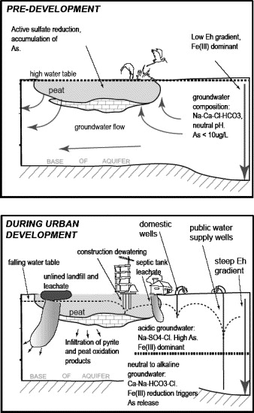
Salts, and nitrates
https://www-sciencedirect-com.ezproxy.library.dal.ca/science/article/pii/S0269749103000721

https://link-springer-com.ezproxy.library.dal.ca/article/10.1007/s10661-019-8037-4

Temperature and groundwater
Transportation with rising temperature in cold weather
https://www-sciencedirect-com.ezproxy.library.dal.ca/science/article/pii/S0012825214001147

https://www.mdpi.com/2073-4441/12/1/224
https://www-sciencedirect-com.ezproxy.library.dal.ca/science/article/pii/S0043135416300422

